Task 1: Labelled Diagrams of a Home Wi-Fi Router and Network Switch
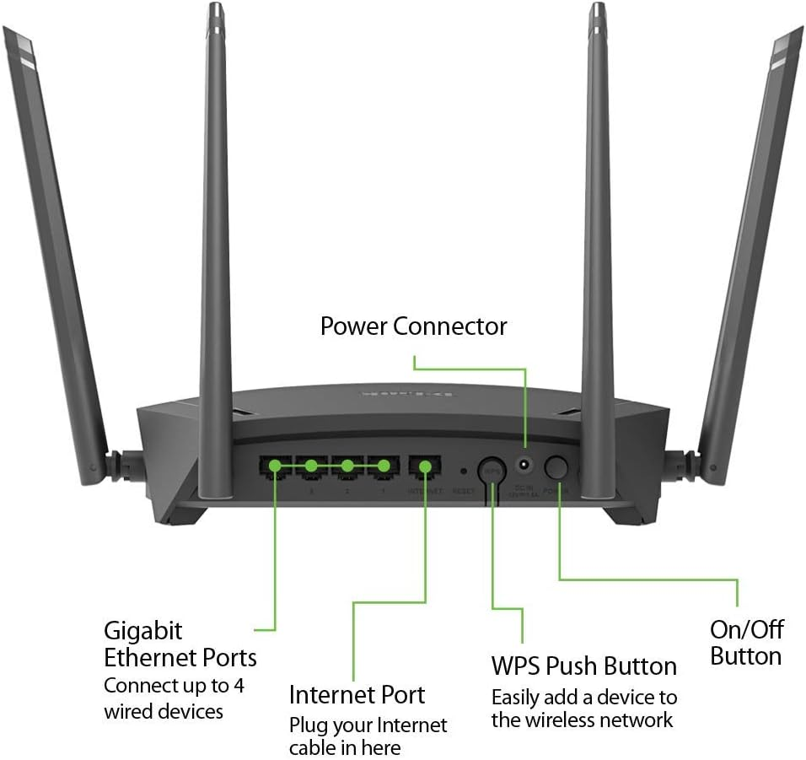
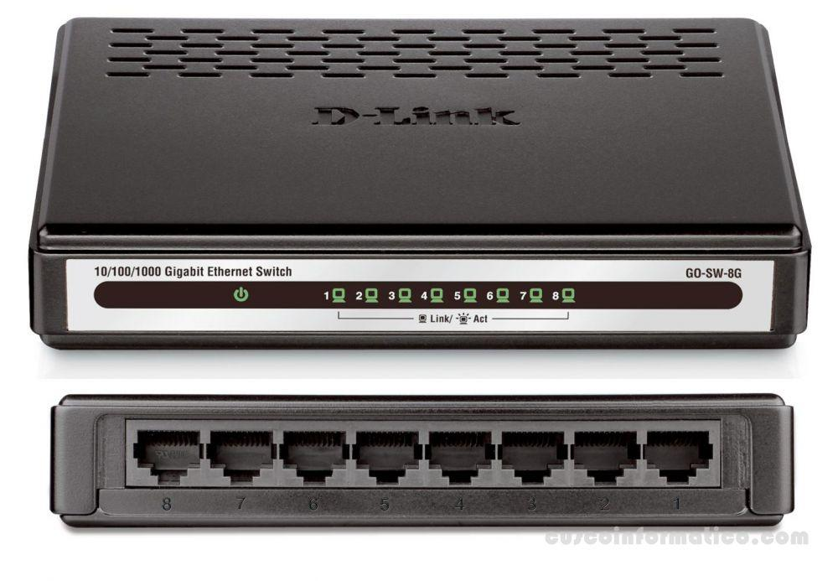

Task 2: Key differences between routers and switches

- IP vs MAC addressing: A router uses IP addresses to decide where to send data between different networks (like your home network and the internet), while a switch uses MAC addresses to send data to the correct device within the same local network.
- What they connect: A router connects two or more different networks together (e.g., your home network to your ISP's network), while a switch connects multiple devices within a single network.
- Intelligence about traffic: A router actively makes routing decisions and can filter/direct traffic between networks (and usually includes NAT, firewall, DHCP), while a switch simply forwards data to the right port based on MAC address without deciding between different networks.

Task 3: Router and Switch Identification

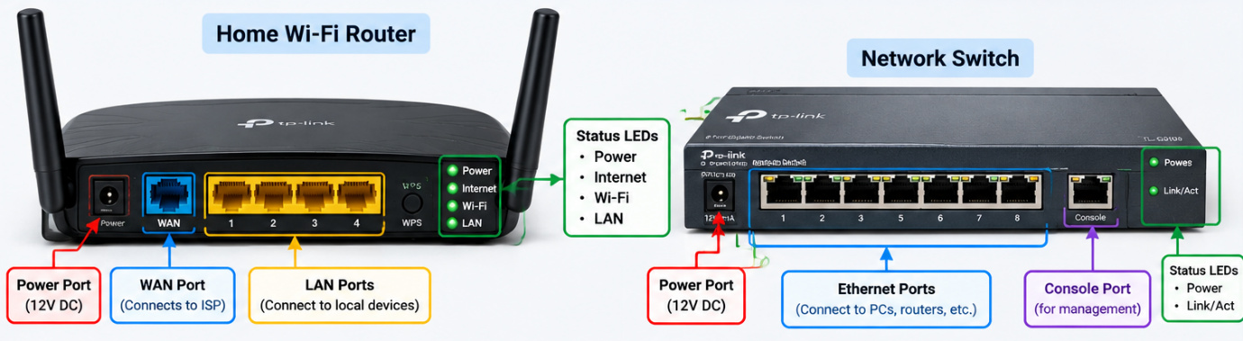
On the router image: The Power port is usually a round barrel jack on one end (often labeled "PWR" or "12V"), the WAN/Internet port is usually a single port set apart from the others that connects to the modem, and 2 or more LAN ports (usually yellow, numbered 1–4) sit next to it for connecting devices by cable. LED indicators are usually on the front panel: a Power LED, an Internet/WAN LED (often turns red if there's no internet), and individual LEDs for each LAN port that blink when active.
On the switch image: An 8-port switch typically has the Power port on one end (barrel jack or a power button for PoE models), followed by a row of identical numbered Ethernet ports (all the same color, since a switch doesn't have a special WAN port). LED indicators are usually placed directly above or beside each port — one LED per port that lights up solid when a cable is connected and a device is detected, and blinks when data is actively being transferred.

Task 4: Gaming Cafe network Deployment Scenario & Justification

Setup Scenario & Connection Topology:
- Connect the incoming ISP Fiber line into the Modem, and connect the modem's output directly into the WAN port of the Router.
- Connect an Ethernet cable from LAN Port 1 on the Router into Port 1 (Tp-link) of a 16-Port Gigabit Switch.
- Run 8 individual Cat6 Ethernet patch cables from ports 2 through 9 of the Gigabit switch directly into each of the 8 gaming PCs.
Justification:
- The router is needed exactly once, to establish and manage the single internet connection and keep the network organized.
- The switch is needed because it cheaply and reliably expands the number of wired ports — a good unmanaged 8/16-port gigabit switch handles the local traffic between PCs (useful for LAN multiplayer, which sends data PC-to-PC without needing to go through the internet at all) with lower latency than Wi-Fi.
- Wired Ethernet (through the switch) is far more important than Wi-Fi here, since gaming and live streaming need low, stable latency — something Wi-Fi struggles with 8 devices active at once.

